# **Airline Analysis**

1. Introduction
   1. Understanding the dataset
   2. What we solved
2. Analyse and visualization
   1. Ticket price
   2. Eight hours long flights
   3. Flights delay
   4. First-class prices
   5. How Inflight Features Impact Cost
   6. Passenger count variations concerning flight duration
   7. Price variations between weekdays and weekends
   8. Coach prices differ for overnight flights
3. Conclusions

## **Introduction**

As a travel agency seeking to optimize the travel experience for clients, understanding the intricacies of airline pricing is paramount. This report delves into a comprehensive analysis of airline prices, aiming to uncover patterns and insights that can aid in securing the best deals for our clientele.

### **1.1 Understanding the dataset**

Our dataset encompasses various factors influencing airline prices, including travel distance, flight details, amenities, and pricing tiers. Key variables include:

* **miles**: Distance covered during the flight
* **passengers**: Number of passengers on the flight
* **delay**: Take-off delay in minutes
* **inflight_meal**: Presence of an included meal
* **inflight_entertainment**: Availability of free entertainment systems
* **inflight_wifi**: Complimentary Wi-Fi on the flight
* **day_of_week**: Day of the week of the flight
* **weekend**: Flight occurrence on a weekend
* **coach_price**: Average price for a coach ticket
* **firstclass_price**: Average price for first-class seats
* **hours**: Duration of the flight
* **redeye**: Indicator for overnight flights

### **1.2 What we solved**

1. Does $500 seem like a good price for a coach ticket?
2. Identifying high, low, and average prices for 8-hour-long flights.
3. What kinds of delays are typical?
4. Do flights with higher coach prices always have higher first-class prices as well?
5. Determining which features contribute most to price increases
6. Analyzing passenger count variations concerning flight duration.
7. How are price variations between weekdays and weekends?
8. How coach prices differ for overnight flights on each day of week?

## **Analysis**

### **Ticket price**

* What do coach ticket prices look like?
* What are the high and low values?
* What would be considered the average?
* Does $500 seem like a good price for a coach ticket?

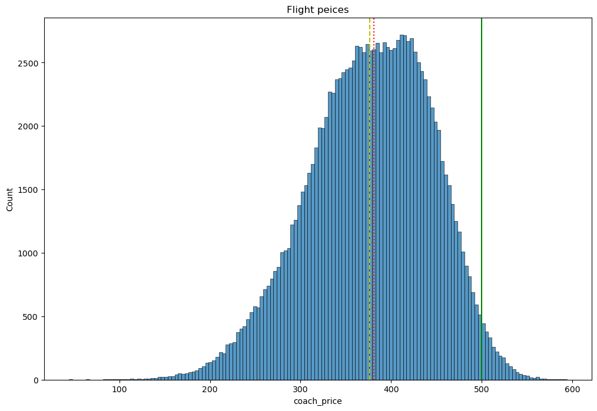

* The average flight price is $376.5 (yellow line).
* Most flights (75%) cost less than $500.
* The mean price is slightly higher at $380.5 (red line).

For budget-conscious travelers, a $500 flight ticket is a great deal! The average price is $376.5, but with 75% of flights falling below $500, this option offers significant savings. While it's not the absolute cheapest, it represents a good balance between price and potentially higher costs associated with flights in the top 25%. Consider factors like your travel flexibility and desired comfort level when making your decision.

### **Eight hours long flights**

* What are the ticket prices for flights that are 8 hours long?
* What are the high, low, and average prices for 8-hour-long flights?
* Does a $500 dollar ticket seem more reasonable than before?

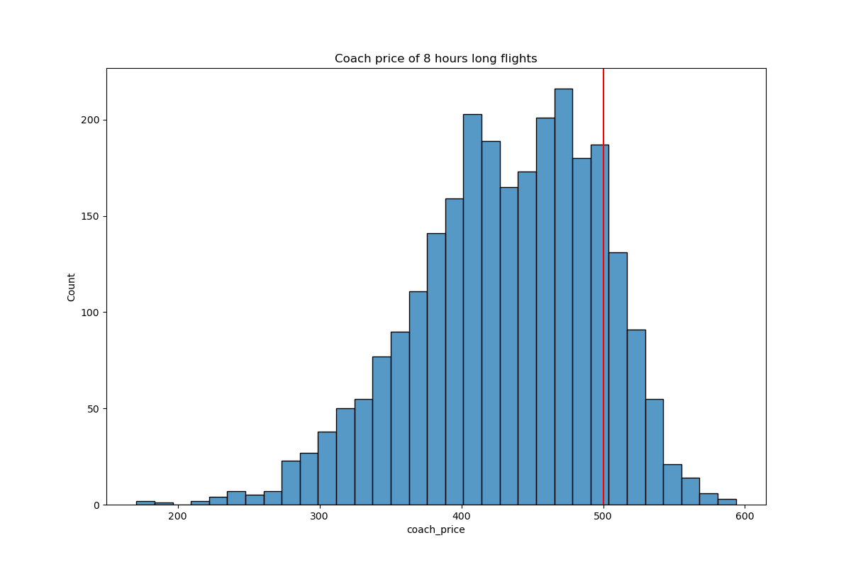

While the average 8-hour flight costs $431.8, a $500 ticket falls within a reasonable range.

### **Flights delay**

* How are flight delay times distributed?
* Let's say there is a short amount of time between two connecting flights, and a flight delay would put the client at risk of missing their connecting flight.
* What kinds of delays are typical?

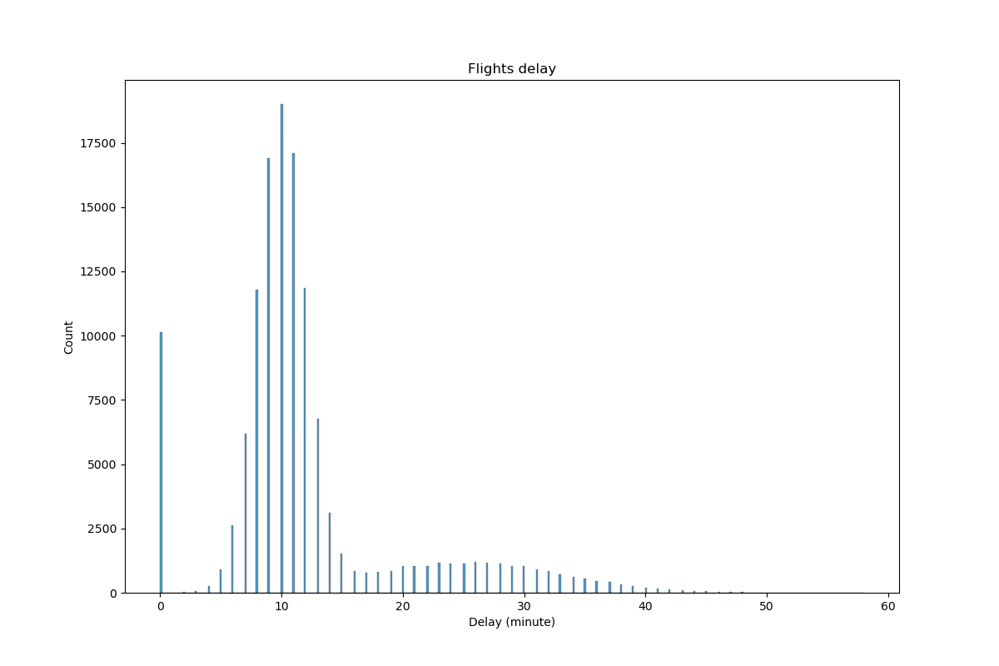

The vast majority of flights (over 90%) experience only 10-minute delays or less. The chance of exceeding 20 minutes is low, though longer delays (up to 45 minutes) are still conceivable.

### **First-class prices**

* What is the relationship between these two prices?
* Do flights with higher coach prices always have higher first-class prices as well?

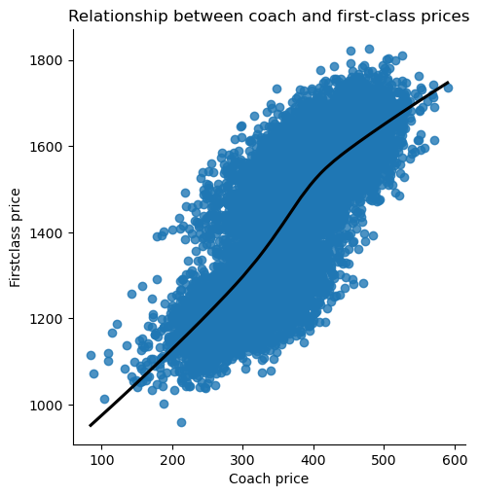

There's a correlation between first class and coach ticket prices, so when coach prices increase, you can expect first class prices to go up as well.

### **How Inflight Features Impact Cost**

* What is the specific impact of different inflight features (meals, entertainment, WiFi) on coach prices?
* Which features are associated with the highest increase in price?

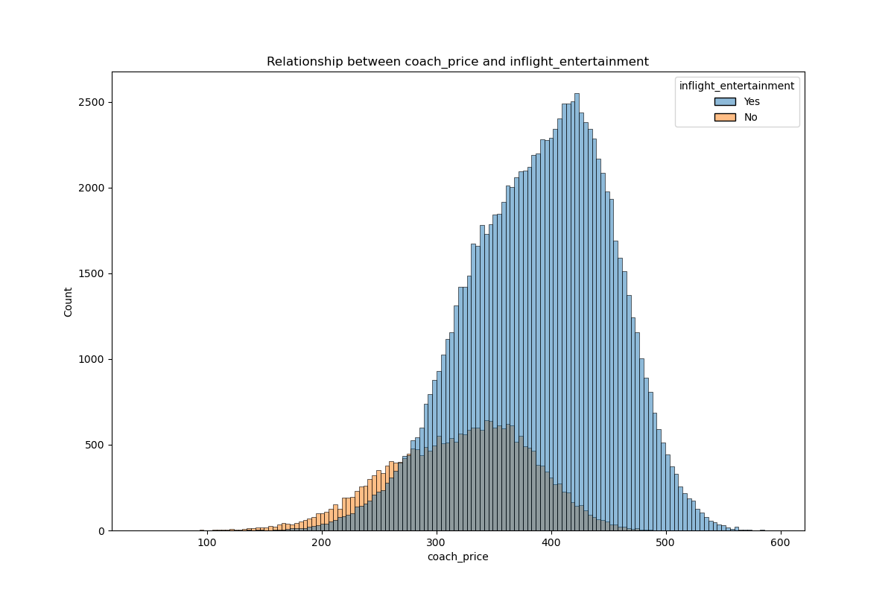

A distinct price-entertainment relationship emerges within the available flights. Those priced below $500 predominantly lack inflight entertainment, comprising less than 20% of the options. Conversely, flights exceeding $280, encompassing even those reaching $600, typically offer such amenities and form the bulk (around 80%) of planes in this category. This suggests a strong correlation between higher ticket prices and the availability of inflight entertainment.

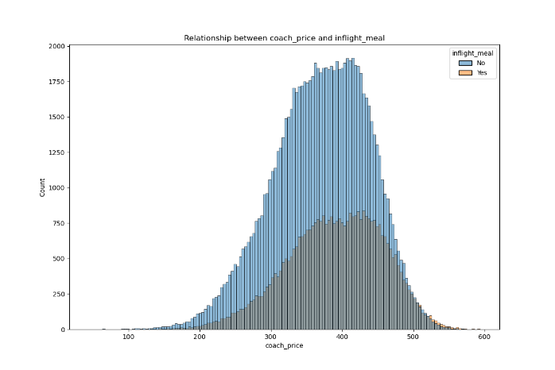

Inflight meals have a minimal impact on ticket prices. This is reflected in the availability of meals across price categories. only about 30% of planes offer inflight meals, regardless of the ticket price.

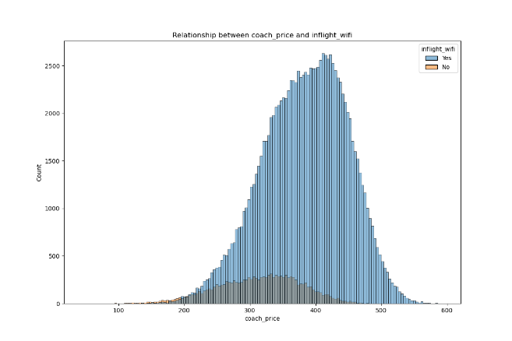

In today's connected world, inflight WiFi has become a crucial amenity for many travelers. Recognizing this, a staggering 90% of all flights now offer onboard WiFi. Fortunately for budget-conscious flyers, access to WiFi generally has minimal impact on ticket prices, although variations may exist across airlines and specific price categories.

### **Passenger count variations concerning flight duration**

How does the number of passengers change in relation to the length of flights?

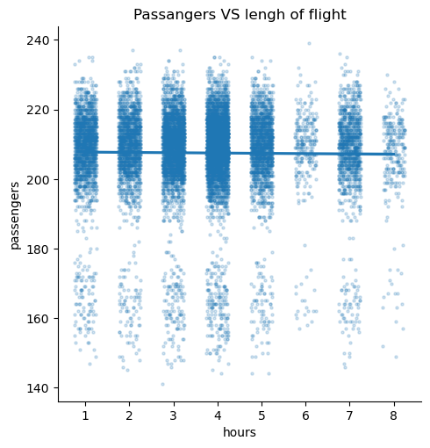

Passengers favor 3-4 hour flights, with the highest density compared to overall count. Conversely, 6-8 hour flights see fewer passengers per flight compared to the total average.

### **2.7** **Price variations between weekdays and weekends**

How are price variations between weekdays and weekends?

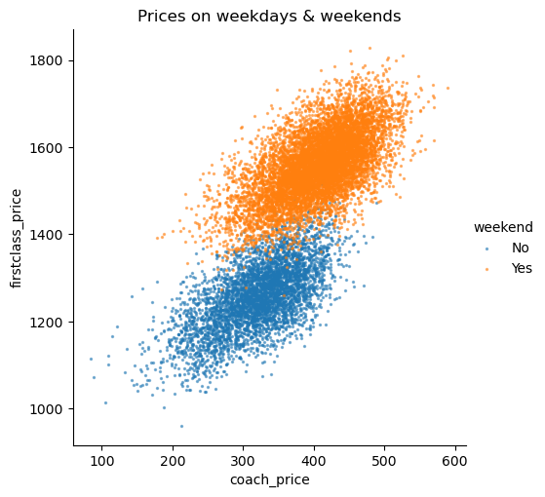

Weekend flight prices exhibit a distinct trend compared to weekdays. First-class ticket prices climb noticeably higher, making deals below $1400 scarce. Coach prices also see a weekend uptick, pushing the threshold for finding fares under $300 significantly higher. Therefore, travelers seeking weekend flights should be prepared for pricier options across both cabin classes.

### **2.8** **Coach prices differ for overnight flights**

How do coach prices differ for overnight flights on each day of the week?

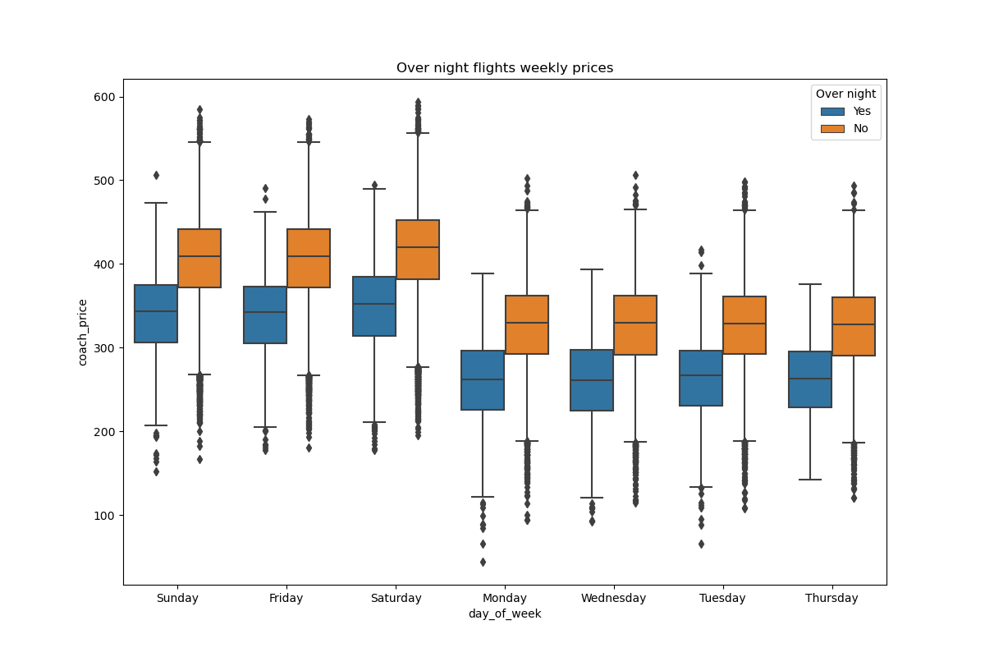

Sleeping beauties save! Over 90% of overnight flights boast lower prices than the cheapest day flights. While Fridays, Saturdays, and Sundays generally see higher airfares compared to other weekdays, even their overnight options offer significantly lower prices than daytime flights on those same days.

## **Conclusions**

* **Pricing:**
  + The average flight ticket price is $380, with 8-hour flights slightly higher at $430.
  + When coach prices increase, first-class prices typically follow suit due to their linked price structures.
  + Inflight entertainment may affect ticket prices, with higher tiers potentially commanding slightly higher fares.
* **Passenger Preferences:**
  + The vast majority of flights experience minimal delays (under 10 minutes), making them attractive to time-conscious travelers.
  + 3-4 hour flights attract the most passengers, likely due to a balance between travel time and cost.
* **Flight Timing:**
  + Weekend flights, particularly on Fridays, Saturdays, and Sundays, see significantly higher prices compared to weekdays.
  + Overnight flights boast lower prices than even the cheapest day flights, offering a budget-friendly travel option.